Student Name | G. Manasa
Student Registration Number | 241U1R3007 | Class &Section: CSE(DS)
Study Level: UG/PG | UG | Year &Term: I & II
Subject Name | Probability & Statistics

Name of the Assessment | Reflective Journal -10
Date of Submission | 12-09-2025

Reflective Journal Template
Journal Entry Guidelines | Description
1. Experience (Class Content) | Briefly describe the topics or concepts discussed during the class.
2. Feelings (Emotional Reactions) | Share your emotional reactions and thoughts during the class.  How did you feel while learning this theory?  Did the class evoke specific emotions or questions?
3. Learning (Key Insights) | Reflect on what you learned from the class.  Highlight the key insights or fundamental concepts you gained from the class.
4. Application (Practical Use) | Describe how you plan to apply the theory you've learned in real-life situations or in your academic/career endeavours.  Explain the practical utility of this theory.

Sample Journal Entry

Date | 12-09-2025
Journal Entry Topic | Regression  Introduction, Regression Analysis, Relation between correlation and regression Coefficients.
1. Experience (Class Content) | In this module we learned about regression. Regression is the measure of average relationship between two or more variables in terms of the original units of the data. In regression analysis there are two types of variables the variable which is influced or are is to be predicted is called dependent variable. And next we discussed about simple linear regression and we discussed about lines of regression there are two lines of regression for two random variables X and Y if X is a independent and Y is dependent then line of regression is regression. And next we learned about regression coefficient the slope of regression line of y on x is called regression coefficient y on x it is denoted by byx.  Byx=$\frac{cov(x,y)}{σ^{2} x}$ = r=$\frac{σy}{σx}$  The slope of regression line x and y is called regression coefficient x on y it is denoted by byy  $byy=\frac{cov(x,y)}{σy^{2}}$= r=$\frac{σx}{σy}$  At last we discussed about properties of regression coefficient the geometric mean between regression coefficient is the correlation coefficient.
2.Feelings (Emotional Reactions) | When I first started learning regression, I felt a little nervous and confused because of the mathematical formulas and new terms like regression coefficient and correlation. It looked difficult and I was worried that I might not understand it. I realized that regression is not only about formulas but also about understanding real-life situations. When I solved some problems correctly, I felt happy and proud of myself. It gave me a sense of achievement. Slowly my feelings changed from fear to confidence and from confusion to clarity. Now I feel excited and motivated to apply regression in real-life problems and future studies.
3. Learning (Key Insights) | 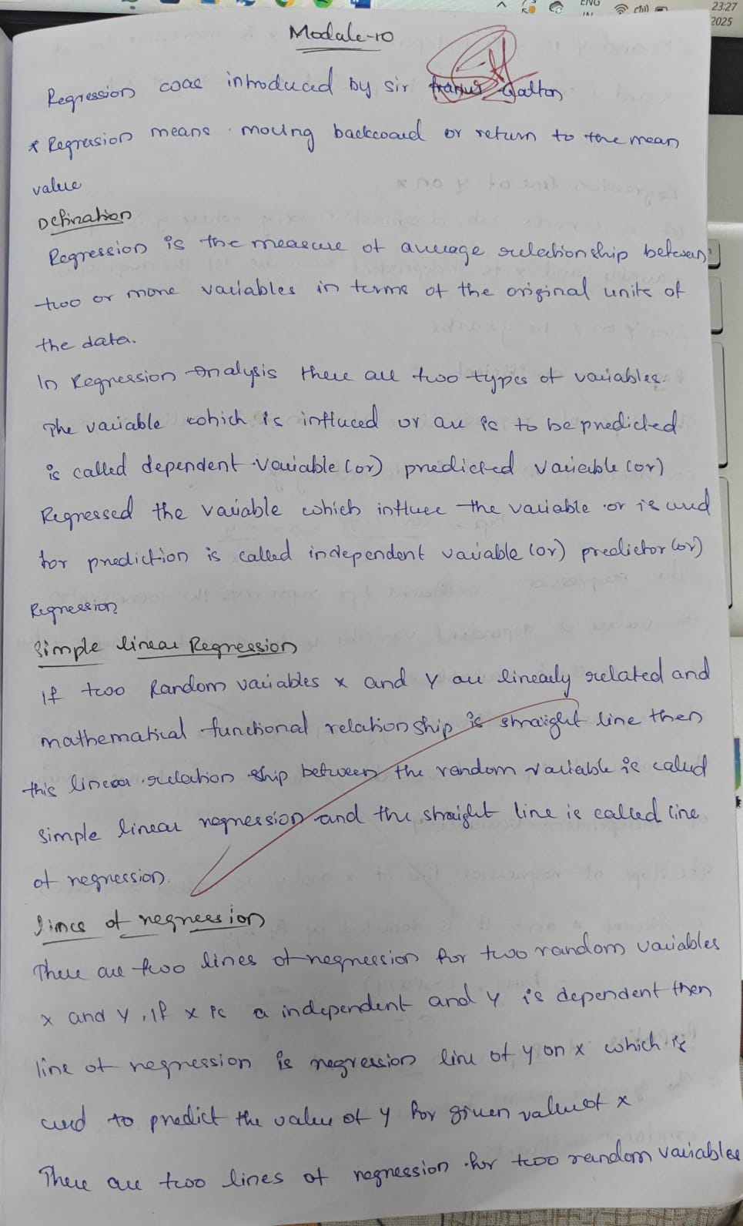  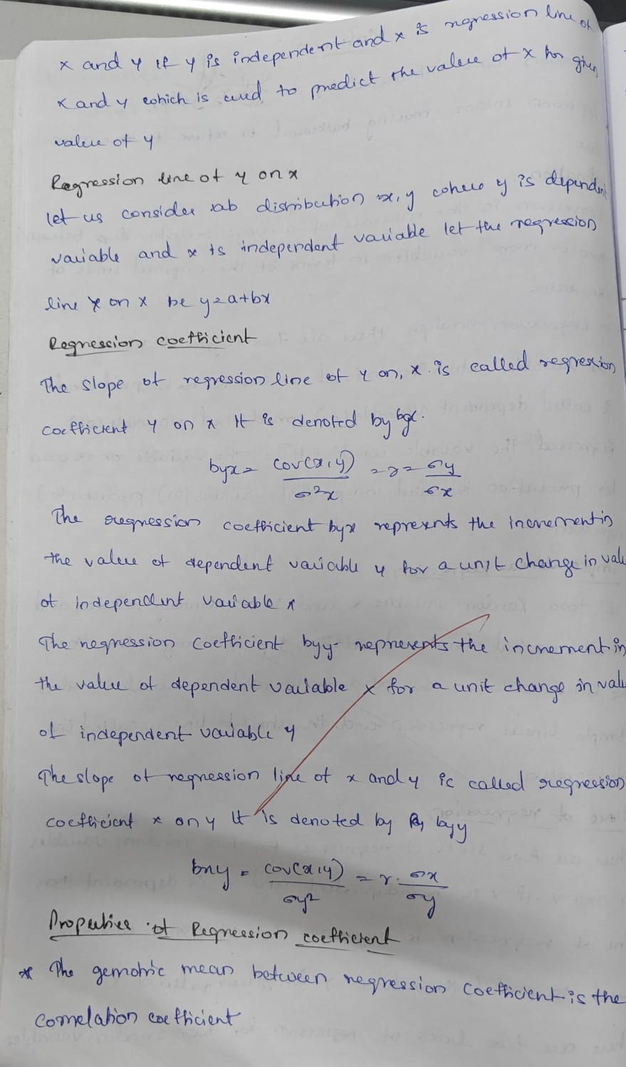  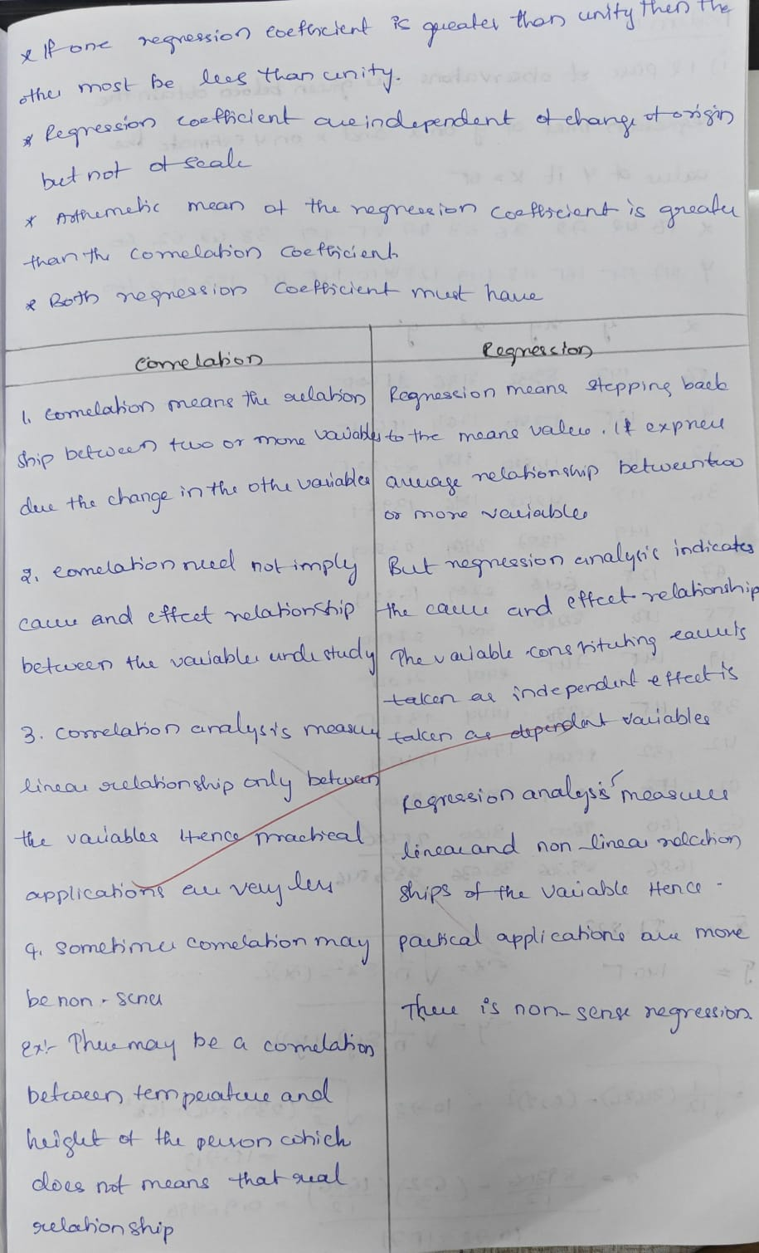  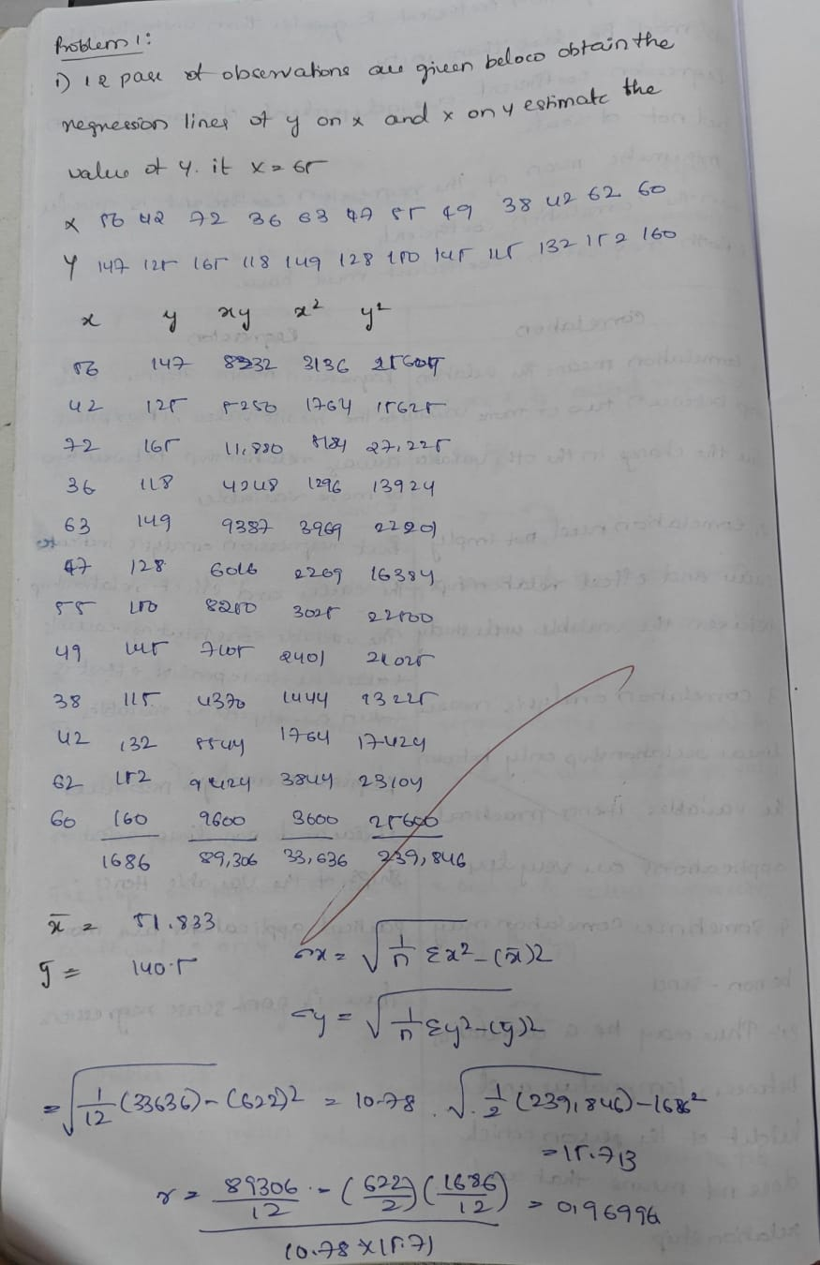
4. Application (Practical Use) | 1. Business and Economics  Regression is used to predict sales, demand, or profit based on different factors.  - Example: A company can predict its future sales (Y) from the amount of money spent on advertising (X).  Equation:  Sales=a+b× (AdvertisingBudget)  - If advertising increases, sales are likely to increase.  2. Education  Regression helps in predicting student performance.  - Example: A teacher can predict exam marks (Y) based on hours of study (X).  If students study more hours, marks are expected to go up.  3. Agriculture  Farmers can use regression to estimate crop yield.  - Example: Crop yield (Y) can be predicted from rainfall (X1) and amount of fertilizer used (X2).  This helps farmers plan better for good production.  4. Health and Medicine  Doctors and researchers use regression to predict health outcomes.  - Example: A doctor can predict a person’s blood pressure (Y) from their age (X1) and weight (X2).  This helps in early diagnosis and treatment.  5. Housing and Real Estate  Regression is useful for predicting property values.  - Example: The price of a house (Y) can be predicted using factors like size of the house (X1), number of rooms (X2), and location (X3).  Real estate companies use this for fixing property prices.  6. Engineering and Science  Regression helps in experiments and research.  - Example: In electrical engineering, power consumption (Y) can be predicted from voltage (X1) and current (X2).  In physics, regression can show how temperature affects material strength.
Conclusion | From this module, I understood that regression is a very useful tool to study the relationship between two or more variables. At first, it looked a little difficult with formulas and coefficients, but later I realized it is very practical and can be applied in real life. Regression is not just theory; it helps in prediction and decision-making in many areas like business, education, health, agriculture, real estate, and science. This topic changed my view about statistics because I saw how numbers and data can explain real situations and even help us plan for the future.

